**Program No: 08**

**Name: Sanio Luke Sebastian**

**Roll No: 35**

**Batch: B**

**Date: 24-05-2022**

**Aim:** Designing Databases using NoSQL: MongoDB

**Procedure & Outputs:**

* To show Database

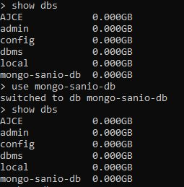

* To create new Database



* To create collection and show it



